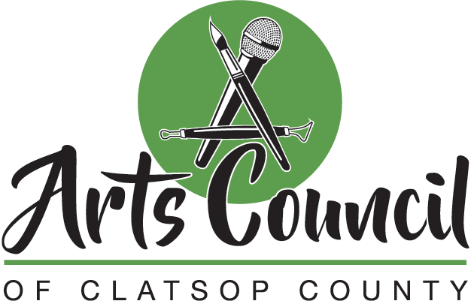
Our mission is to support, promote, and advocate for the arts and cultural enrichment in the county.
We envision Clatsop County as an arts mecca, where every citizen's creativity has an outlet, public art lives in abundance, low-cost art is accessible across demographics, and the public is aware of the economic importance of art.

Minutes of the Council Meeting, September 29, 2022
Ten Fifteen Theater, 1015 Commercial Street, Astoria

1. Meeting called to order at 11:00 am. Present: Sheila Martin (President), Dave Ambrose, Sarah
Andrews-Collier, Katherine Lacaze, Danyelle Tinker, Patrick Willis. Absent: Lorri
Thompson

2. Approval of Agenda. Danyelle/Dave moved approval. MOTION PASSED by unanimous voice
vote.

3. Approval of the Minutes of 8.26.22. Dave/Patrick moved approval. MOTION PASSED by
unanimous voice vote.

4. Council briefing. Sheila reported that the Communication Committee for the website and Google
Drive is Katherine, Lorri, and Sheila. ACCC Google addresses are optional for internal
communication, with the exception of Sarah and Danyelle who prefer to use theirs. Sarah
will continue to monitor Facebook.

5. Near future.
Clatsop County Cultural Coalition grant RFP (due October 31). Sheila and Patrick will attend live and virtual county workshops on October 5 and 7. Potential asks are Make Music Day (June 2023) or the next Summit (Fall 2023).

Astoria Ukulele Orchestra. They recently performed in Gearhart and are scheduled for another on November 5 @7 at Ten Fifteen. A template for fiscal sponsorship of the group by the ACCC was distributed with the agenda. Katherine/Dave moved we accept the agreement. MOTION PASSED by unanimous voice vote.

Make Music Day December 21, 2022. More in depth planning is scheduled for the October meeting.

Art Card. Sheila and Danyelle will work on details, with a potential rollout in January 2023.

Logo revision. We are still seeking a designer. Kate and Dave have ideas for candidates.

6. Minutes and commitments review (assignments)
Website progress. Katherine reported that it is up and running. Sheila suggested we add information about our donations to AVA camps and the Clatsop-Nehalem mural restoration.

Fall theater workshops. Katherine proposed a budget of $1500: 8 stipends of $100; $300 for lunches; $100 for materials; $300 for transportation and substitute costs. The Coaster Theater space has been donated. Danyelle/Dave moved the budget be approved. MOTION PASSED by unanimous voice vote. Sheila, Kate and Sarah will assist at the workshop

Minutes of the Council Meeting, September 29, 2022, p. 2 of 2

Board member vacancies (two positions plus student non-voting member). Sheila, Kate and Sarah interviewed candidate Laura Janes, and recommended that she join the council. Sarah/Danyelle moved approval. MOTION PASSED by unanimous voice vote.

7. Main discussion topic: AEP6 Survey (discussion, assignments)

Listing and signup for events in October; Sheila requested that if folks can’t make a
commitment they find a substitute.

Events covered so far and numbers: 87 paper, 68 QR through 7 September (155: 19.4% of
800)

Confirm list of county nonprofits and add faith-based organizations as requested by AEP6.

8. Liaisons reports (information)

• AEP Arts Services Oregon meeting
• Arts Services Oregon September 26

9. Financial report. Lorri was absent.

10. Outside factors (discussion)

11. Next meeting date and adjournment. The next meeting was scheduled for October 21, 2022 at
11:00 am in Seaside. The meeting adjourned at 12:30 pm.

