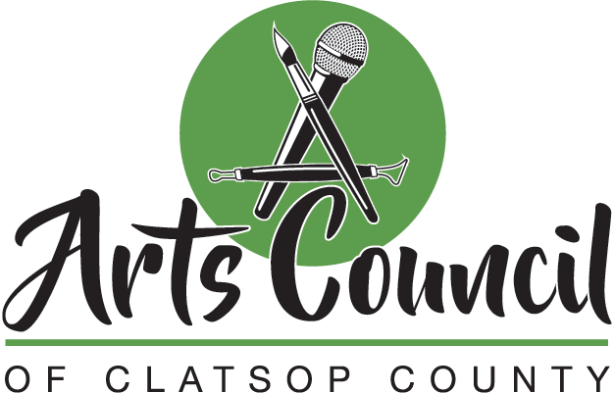
Meeting Minutes
January 28, 2022 at 11:00 a.m.
Ten Fifteen, Astoria
Present: Dave Ambrose, Scott Justus, Sheila Martin, Danyelle Tinker, Katherine Lacaze, Jennifer Crockett
Absent: Sarah Andrews-Collier
- Meeting called to order by Sheila Martin at 11:02 a.m.
- Approval of agenda moved by Danyelle, seconded by Dave, motion approved
- Approval of 12/14/2021 minutes moved by Jennifer, seconded by Dave, motion approved
  - With amendment to add “research” to 7E regarding insurance
- Council briefing
  - Scott shared information on the Astoria – Warrenton Area Chamber of Commerce
    - Sarah moved to join the chamber, Dave seconded, motion approved
  - There was discussion on the Nonprofit Association of Oregon
    - Katherine moved to join the NAO, seconded by Jennifer, motion approved
- Near future
  - Fundraiser at the PAC – March 27th
    - ACTION: Put poster on Facebook
    - ACTION: Set up Square account for donations
  - Check from County for $3850.32 in account
  - Danyelle to check on G Suite
  - Connecting with Business Oregon’s Becky Bryant
    - They fund Oregon Arts Commission
    - Make Music Day
      - Tuesday, June 21st
      - Need list of groups or musicians
      - Could do open jams in each city - reach out
      - ACTION: provide names and contact information for musicians and possible venues to Sheila
      - Sheila moved to participate in Make Music Day, seconded by Jennifer, motion approved
- Minutes and commitments review: strategic plan progress
  - DEI at the Liberty
    - Contracted with Lillian
    - Trains and sets up coalition
    - Diversity audit
    - $10k cost covered by the Collins Foundation
      - Will assist in grant writing
  - Insurance
    - Getting feedback that insurance companies can’t advise, and nonprofit may choose
  - Website
    - Katherine has a vision
  - Oregon Festivals & Events Association
    - See Sarah’s report
      - Will revisit discussion
- Main discussion topic: Strategic plan
  - Change contract to hire
    - Dave moved, Jennifer seconded, the motion to approve the strategic plan with the word change was approved
  - Need more council members and looking for diverse representation across the county specific to council needs
    - ACTION: Outreach to potential members
  - Board training
    - Coaster went through board training
- Liaison Report
  - No liaison report
- Outside factors: has anyone learned anything since our last meeting that may affect the Arts Council?
  - Grange update
    - Surge of new members
    - Maypole event – May 8th
  - Individual Artist Relief Fund now open
    - Through Oregon Arts Commission
- Reflections
  - Ten Fifteen Theater opens February 11th
- Next meeting at Ten Fifteen Productions on February 25th at 11 a.m.
- Meeting adjourned at 12:32 p.m.

